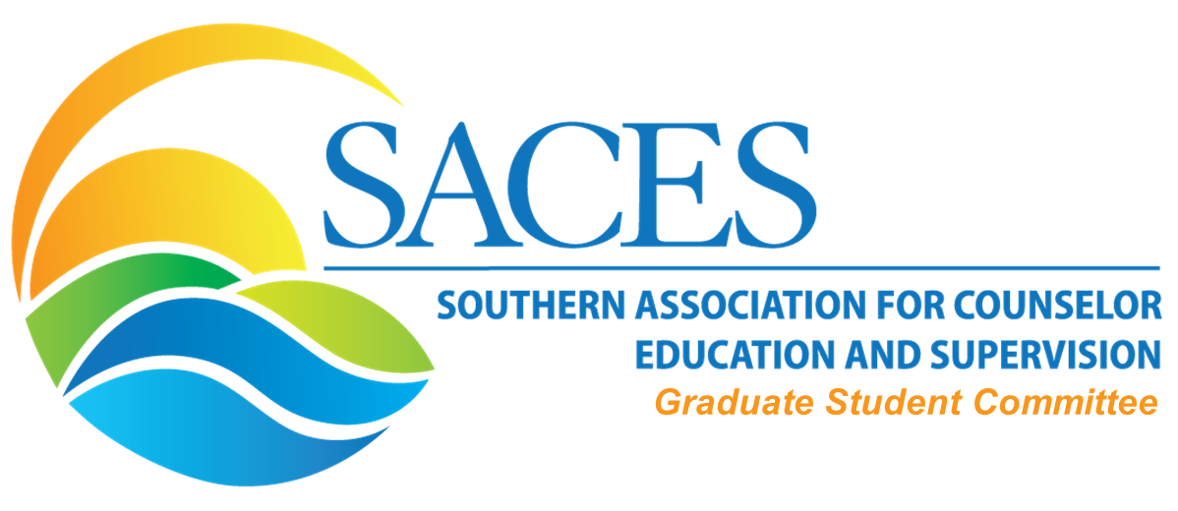

Committee members present: Raven Cokley, Jose Tapia-Fuselier, Hannah Coyt
Meeting Date: August 23, 2019 3-4 PM (CST)

Agenda

  - Reports/updates from each workgroup
      - Blog Workgroup
        - Needs? Supports?
        - Active people: 4-6
      - Interviews Workgroup
        - Needs? Supports?
      - Newsletter Workgroup
        - Needs? Supports?
      - Collaboration with Interest Networks Workgroup
        - Needs? Supports?
      - Social Media
        - Needs? Supports?
- Involvement (Application Process)-Continued work on this area
  - Discuss commitment/needs
    - limiting 6 people per work group and the rest being moved to work with the interest network with lower level of commitment.
    - Does any work group have more than 6 actively involved?
  - Reasons to be involved with GS workgroups
    - Professionalism
    - CV
    - Names on website page under each committee (visibility)
- ACES Student Lounge in Seattle
  - Google Form Selection: Tips On Completing the Dissertation Process
    - 6 people max representing various aspects of the dissertation process.
- Timeline
  - Next Meeting - September (doodlepoll)
  - Submitting application (google form)
  - Call for Graduate Student Interest Network

Committee Co-Chair: Hannah M. Coyt
Email: grad.rep@saces.org

Committee Co-Chair: Jose “Joey” Tapia-Fuselier
Email: grad.rep@saces.org

Link to the August meeting:

https://unt.zoom.us/recording/share/3SJ1n4w9g-ntYeOAie_48gz2iq_NYtjGyl0zxQuE4aiwIumekTziMw

